{"errors":[],"outputs":[{"available_years":[1994,1995,1996,1997,1998,1999,2000,2001,2002,2003,2004,2005,2006,2007,2009,2011,2012,2013,2014,2015,2016,2017],"comments":null,"confidential":false,"inverter_mfg":"Fronius","inverter_model":"IG 4500-LV","module_mfg":"Siemens","module_model":"M55 c-Si","site_power":6000.0,"module_tech":null,"name_private":"SERF, Serf West Systems","name_public":"[51] NREL x-Si #7","site_area":null,"site_azimuth":158.0,"site_elevation":1994.7,"site_latitude":39.7416,"site_longitude":105.1734,"site_tilt":45.0,"system_id":51}],"warnings":[],"infos":[],"inputs":{"site_url":"pvdaq/v3/sites.json","system_id":"51"},"version":"3.1.0"}

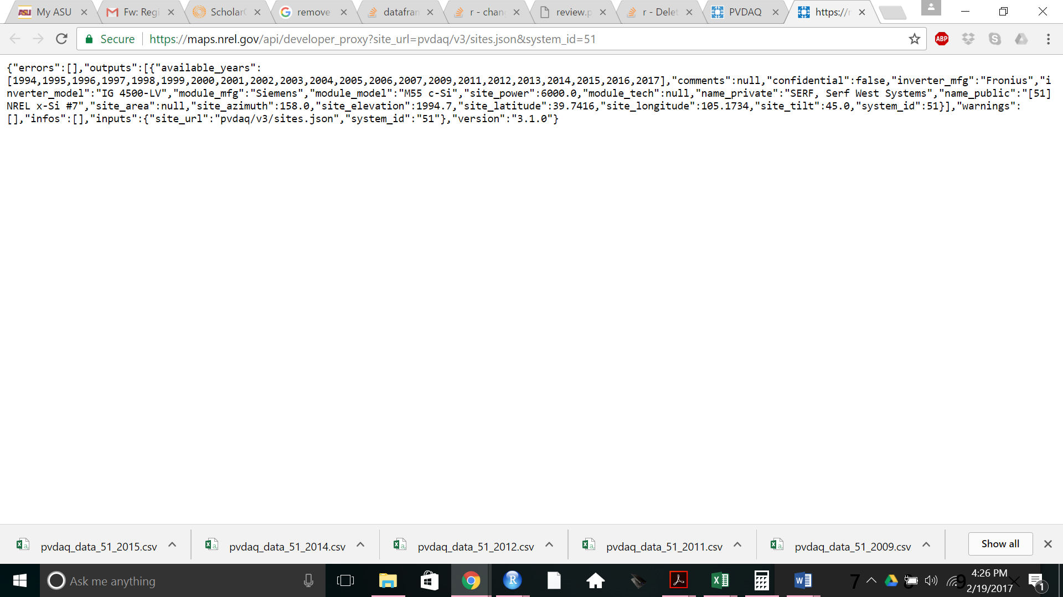

Site 4

|  |  |
| --- | --- |
| *Latitude* | 39.7406 |
| *Longitude* | 105.1774 |
| *Elevation* | 1795.3 m |
| *Azimuth* | 180 |
| *Tilt* | 40 |
| *Rating (DC)* | 1 kW |
| *Module Mfg.* | Sanyo |
| *Module Type* | HIP 200-BA3 |
| *Module Tech* | 1 |
| *Inverter Mfg.* | SMA |
| *Inverter Type* | 1800 |